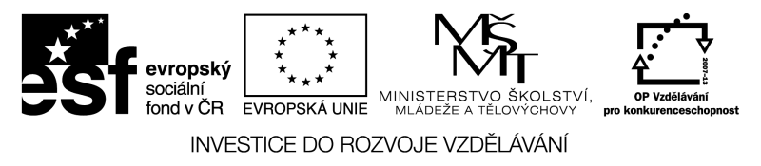
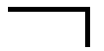

START
SČÍTÁNÍ |  |  |  |  |  |  |  |  |  |  |  |  |  |  | CÍL
 |  |  | 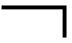
 |  |  |  |  |  |  |  |  |  |  |  | NÁSOBENÍ
 |  |  |  |  |  |  |  |  |  |  |  | 
 |  |  |  |  |  |  |  |  |  |  |  |  |  |  | 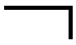
 |  |  |  |  |  | 
 |  |  |  |  |  |  |  |  |  |  |  |  |  |  | 
ODČÍTÁNÍ
 |  |  | 
 |  |  |  |  |  |  |  |  |  | 
 |  |  |  |  |  |  |  |  | 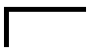
 |  |  |  | 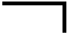 |  |  |  |  |  |  |  | POROVNÁVÁNÍ

